

**Rebuilding Confidence in the Financial System**

Speech given by

Sir John Gieve, Deputy Governor, Bank of England

At the BBA’s 12th Annual Supervision Conference 28 October 2008

1

All speeches are available online at [www.bankofengland.co.uk/publications/Pages/speeches/default.aspx](http://www.bankofengland.co.uk/publications/Pages/speeches/default.aspx)

We are publishing today our bi-annual Financial Stability Report, and so I want to start my presentation by looking at the wider context of the debate on supervision, on which this conference is focusing.

The word unprecedented is used too frequently. But the instability in financial markets over the last year – culminating in the seizure of money markets in recent weeks (Chart 1) – has been the most severe in living memory.

It did not come out of the blue. The price of risk especially in credit markets had fallen to unsustainable levels by summer 2007 and many banks and other institutions had become reliant on sustained liquidity in new markets which had never had been tested by a downturn. In the July 2006 FSR, for example the Bank warned of “UK banks’ increasing dependence on wholesale funding” and, in April 2007, we noted that: “if UK banks were unable to securitise existing assets, new lending would need to be financed through other wholesale sources, which may be difficult or costly to access during times of stress.” So it proved.

But the Bank was not alone in pointing to the vulnerabilities in the financial system in 2006 and 2007. Other commentators and authorities gave similar warnings. And many market participants were also expecting a correction at some point; but they generally felt they were well placed to handle it. In fact the severity and breadth of the downswing has surprised markets, commentators, and policymakers alike.

In the light of subsequent developments, a number of commentators have concluded that the problem was simply a lack of attention and short memories. I don’t think it was quite as simple as that. I am with Mark Twain who said "History doesn't repeat itself, but it does rhyme." While the current crisis has some similarities to previous downswings – in the early 90s or of the 70s for example - there are some significant differences too.

For example the last three recessions in the UK (in the 70s, 80s and early 90s) were preceded by sharp rises in consumption and activity and earnings to well above sustainable rates. As Chart 2 shows that was not true of the last few years when consumption, output and earnings all seemed unusually stable.

Again in previous recessions, stress in the banking sector has tended to follow on from defaults and losses on domestic loans as interest rates rise and the economy slows down. But this time the downturn started in the banking sector - last summer when losses in the US property market not only led to losses in UK banks trading and

treasury books but closed important sources of finance to them. The downturn in the housing market and then the wider economy followed. Domestic default rates, while beginning to rise, are still low by historical standards, despite the fact that we are more than a year into the crisis.

Those differences reflect the most important distinguishing feature of this downturn, namely its roots in global imbalances not just in trade but in the financial system.

The growth and savings in emerging economies led to an extraordinary flow of funds back to the developed world and to the US in particular. That in turn kept interest rates low, allowing the rapid growth of credit and fuelling a sharp rise in asset prices and an increasingly risky search for yield – for example in sub prime housing in the US.

The impact in the UK was different but no less marked. Here too the low cost of credit fuelled a spectacular expansion of bank balance sheets (Chart 3) and with it a growth in leverage (Chart 4). And, as Chart 5 shows, while savings rates fell in the UK, limiting the growth of retail deposits, banks financed that lending by tapping wholesale markets. The gap between customer lending and deposits moved from zero at the turn of the century to over £700 billion in 2008 H1.

Much of that funding was ultimately sourced overseas. In particular, the United States acted as an intermediary, attracting capital inflows from the rest of the world and exporting these funds to other countries. Road shows to investors in the US and Europe ceased to be the preserve of the international giants and became common among smaller players whose whole asset base was in the UK.

As the difficulties in the financial system have persisted and worsened, it has become clear that these developments have created real structural weaknesses in the banking sector. In particular:

* inflated aggregate balance sheets, whose expansion had outpaced growth in the real economy;
* expansion into assets whose underlying value, credit quality and liquidity were uncertain;
* liability structures which were overly reliant on sustained availability of wholesale funding whose maturity was often short;
* capital and liquidity buffers which became too low , given these asset and liability risks; and
* underappreciated, but potent interconnections between firms in the global financial system.

# Policy response

For most of the last year, the Bank has adopted a twin track approach, as part of the Tripartite partnership with the FSA and the Treasury. The first track has been to provide liquidity to the market in order to give most banks time to make the necessary adjustments – including by raising capital. That has involved an increasing range of measures including long term repos on a wide range of collateral and the introduction of the Special Liquidity Scheme which allows banks to swap illiquid assets for Treasury Bills for periods of up to three years. The recent dollar swaps and further extensions of the SLS and eligible collateral are further steps in that direction. And we recently announced a more permanent structure of money market operations including the introduction of a discount window.

The second track has been to work closely with the FSA and Treasury to limit the repercussions from the failure of banks which do not have an independent future whether through arranging mergers or managing closure. Northern Rock was the first in line and led to a lot of criticism of the tripartite. I think we have learned a great deal over the year and have shown more skill and speed with subsequent cases including Bradford and Bingley recently.

But in the last 6 weeks it became clear that this case by case approach was not enough either at home or internationally. Despite the provision of additional liquidity to the system, market conditions got worse over the summer as worries grew about the downturn in the broader economy and its consequences for bank losses.

Once again the triggers for a further downward lurch came in the US. First Fannie Mae and Freddie Mac were taken into conservatorship and then, the following weekend, Lehman Brothers proved unable to find a buyer and filed for bankruptcy. That shook markets which had expected it to be saved by the State, if necessary, as had been the case with Bear Stearns earlier in the year.

Within a day, AIG had to be rescued following rumours about the size of its losses on CDS contracts and pressures grew on the remaining securities dealers. Later in the

week, Secretary Paulson announced his initial $700 billion plan to purchase assets to support the banking sector. It didn’t entirely still the doubts.

The pressures were also felt in Europe. At the end of September Dexia, Fortis and Hypo Real Estate all had to receive emergency capital injections, mostly government supplied. In the UK the authorities facilitated a rapid consolidation in the mortgage sector with Abbey Santander buying Alliance and Leicester, some mergers in the building society sector, and the proposed merger of LTSB and HBOS. Finally, in late September the Tripartite authorities intervened to resolve growing difficulties in Bradford and Bingley by transferring the deposits and branch network to Abbey Santander and taking the remaining assets and liabilities into public ownership for orderly wind down.

But the loss of confidence went wider than a subset of vulnerable banks. Our report estimates the total US and European marked to market losses on credit assets at nearly $2.8 trillion. While these will not all fall on banks and may exaggerate the losses to those who can hold debt to maturity, investors and counterparties became worried about the extent of the likely losses on banking and trading books in a wider range of institutions and in their ability to continue to finance their businesses. The focus of their concerns shifted from future profitability to future survival. CDS premia rose to unprecedented levels (Chart 6), bank equity prices fell sharply and the money markets seized up. Interbank lending spreads widened dramatically (Chart 7) and lending became almost entirely concentrated in the overnight market. The shortening of interbank maturities generated a dangerous ‘snowball’ effect as maturing term funding had to be rolled overnight.

It was to tackle that wider loss of confidence that the UK authorities announced on 8th of October its comprehensive package of support for recapitalisation, guaranteed funding and enhanced liquidity. It was designed to remove solvency fears by ensuring that banks had more than sufficient capital to survive a severe economic downturn and thus to enable them to continue to lend on normal criteria to good credits.

The new capital and the government guaranteed borrowing and liquidity support was designed to ensure and be seen to ensure that banks would be able to sustain their businesses through a downturn. With the banking system fully solvent, guarantees could be extended without exposing taxpayer to unacceptable risks. In a remarkable show of international consensus, a similar approach was quickly adopted by many other countries both in the US and EU and more widely.

# Looking ahead

The early signs suggest that the package is underpinning the banking system both directly and as a demonstration of the authorities’ determination to do whatever is needed to re-establish confidence. In particular CDS premia for banks have fallen markedly (Chart 6) since the package was announced. And progress on guarantees, while gradual, has also been encouraging, with a number of banks issuing bonds even without the use of the guarantee. Libor spreads have also edged down and are now expected to fall a bit further and faster than before the package (Chart 8). Many banks continue to face a period of deleveraging and rebalancing to reduce their dependence on Central Bank finance and on short term wholesale funding. However a stronger capital and financing position will make it possible for them to do that over a period of some years, which will diminish the squeeze on lending in the short run.

More widely, of course, the financial system remains under acute strain. The falls in equity markets, corporate bond prices and the prices for leveraged loans is hitting both long term institutional investors and leveraged investors, including hedge funds. Some are being forced to sell into a falling market in response to margin calls and redemptions.

And there are growing signs of stress in many emerging market economies. We have already seen a banking sector and currency crisis in Iceland and in the past few days the IMF has also announced loan packages for the Ukraine and Hungary.

In short, the package of measures introduced in the UK and elsewhere has improved the prospects significantly, especially for banks but it is too soon to declare the crisis over. Authorities worldwide need to remain vigilant and to be ready to step in again if necessary.

# The medium term agenda

We all have lessons to learn from the turmoil of the last fifteen months. I would like to pick out three in particular, two of which are international and one UK specific:

* the need to develop new “macro prudential” policies to bridge the gap between monetary policy and the regulation of particular institutions and markets;
* the need to establish a more effective regime in the UK for handling failing banks; and
* the need to improve the handling of cross border crises and bank failures.

Central Banks have always paid close attention to asset prices and credit growth in deciding monetary policy but they are setting interest rates for the whole economy and there is no guarantee that the rate or the rapid changes in rates that could be needed to dampen asset price growth will be appropriate more widely.

On the other side, regulation and supervision are focused on the resilience and conduct of individual institutions: their management, risks controls, capital and liquidity and so on. What we have found in the last few years is that the sum of what makes sense at the level of individual institutions does not necessarily add up to what is needed for the system as a whole.

We need to develop what are called “macro prudential” policies to bridge that gap. In particular we need to establish stronger restraints on the build up of risks in the financial system over the cycle with the dangers they bring to the wider economy.

That means not just increasing capital and liquidity requirements for individual institutions but relating them to the cyclical pressures in the system more broadly.

One way of doing that has been developed in Spain. It is called “dynamic provisioning”. Chart 9 illustrates how it works. It requires banks to build up a general loss reserve during good times, based on past experience of likely losses on new lending. The effect is to build up reserves when loans are originated which can then be drawn down when the economy begins to deteriorate and actual losses are incurred. That would lessen the need to raise capital in downturns. And as draw downs on these general provisions would be automatic, the market should not view this as negatively as reductions in regulatory capital ratios.

The second lesson comes directly from our experience with Northern Rock where even after the bank had become totally dependent on the State, there was no legal framework for resolving its future quickly and effectively. No regulatory regime can prevent all bank failures. So it is important, for financial stability, that any such failures are orderly. That is the role of the Special Resolution Regime, a key component of the Banking Bill.

The SRR gives four tools to the three Tripartite Authorities to cope with failing institutions:

* First, the transfer of all or part of a bank’s business to a private sector purchaser; something we have already seen used in the resolution of Bradford and Bingley and Kaupthing under the Special Provisions Act.
* Second, the transfer of the viable part of a bank’s business to a temporary bridge bank owned by the Bank of England. This would allow continuity of banking services for its customers whilst enabling due diligence by potential private sector purchasers and providing for the orderly wind down of the rump.
* Third, temporary public ownership which would give the treasury the power to transfer the shares of a failing bank to a nominee of the Treasury. This power would be used in cases where significant amounts of public sector funds are required to stabilise the failing bank or where long term restructuring of the bank is necessary.
* Fourth bank insolvency procedures - a last resort. This would look much like a standard company insolvency but with the important difference that the liquidator’s primary objective would be to assist the FSCS in protecting depositors.

I can understand why there has been some nervousness among banks and investors about this regime and particularly about the powers to split failing banks into “good” and “bad” parts. But equally I think they can see that when a bank is failing it is in everyone’s interests to resolve the situation quickly and cleanly. I hope that they will be reassured by the extensive safeguards we are now proposing, including the guarantee that no creditor will be made worse off in such a split than they would have been in a conventional insolvency and protection of netting and set-off.

Finally, the financial turmoil has also revealed the need for better international crisis management. The experience of Lehmans has shown once again the problems that arise in the insolvency of a large international bank with operations in many countries. We also saw in late September and early October the danger emerging, of the banking equivalent of the old beggar thy neighbour policy on currency depreciation, as individual countries began to guarantee their own banks’ debt. On the other side, recent events have also demonstrated how effective international action can be: the coordinated interest rate cuts on the 8th of October; the provision of dollar liquidity by central banks and the adoption of national measures to support banks at international meetings during the weekend of 11/12 October.

International groups such as the Financial Stability Forum (FSF) have already started to take action. It has begun to develop a practical checklist of issues and principles that should guide the management of a distressed cross-border institution.

Having started with Mark Twain I want to finish with another quote this time from from Santayana:

‘A man’s memory may …become the art of continually varying and misrepresenting his past, according to his interests in the present.’1

One lesson from recent events is the need for rigour, balance and transparency in policy making and risk assessment. I hope that the Bank can play a part in that in future as it has in the past.

1 “Reasons and places”, George Santayana.

|  |  |  |  |  |  |
| --- | --- | --- | --- | --- | --- |
| **Chart 1: Financial market liquidity** | **Chart 2: Household consumption growth: what happened to the boom?** | | | | |
| Liquidity index  1.0  0.5  + 0.0  -  0.5  1.0  1.5  2.0  2.5  92 94 96 98 00 02 04 06 08  Sources: Bank of England. Bloomberg, Chicago Board Options Exchange, Debt Management Office, London Stock Exchange, Merrill Lynch, Thomson  Datastream and Bank calculations |  |  |  |  | Percentage changes on a year earlier |
|  |  |  |  | 10 |
|  |  |  |  | 1973 Q3 8 |
|  |  |  |  | 1980 Q1 6 |
|  |  |  |  | 1990 Q3 |
|  |  |  |  | 2008 Q3 4 |
|  |  |  |  | 2 |
|  |  |  |  | 0 |
|  |  |  |  | -2 |
|  |  |  |  | -4 |
|  |  |  |  | -6 |
| -16 | -12 | -8 | -4 | 0 4 8 12 16 |
|  |  |  |  | Quarters |
| **Chart 3: Bank lending to households and non- financial companies in the UK** | **Chart 4: Major UK banks’ leverage ratio** | | | | |
| Percentage of GDP  100  90  80  Households 70  60  50  40  30  20  Non-financial companies 10  0  70 74 78 82 86 90 94 98 02 06  Sources: Bank of England, Thomson Datastream and Bank calculations. | Sources: Published accounts and Bank calculations | | | | |

Percentage of GDP

100

90

80

Households 70

60

50

40

30

20

Non-financial companies 10

0

70 74 78 82 86 90 94 98 02 06

Sources: Bank of England, Thomson Datastream and Bank calculations.

|  |  |
| --- | --- |
| **Chart 5: Major UK banks’ customer funding gap, household saving ratio and foreign interbank deposits** | **Chart 6: Major UK banks’ and LCFIs’ credit default swap premia** |
| Sources: Bank of England, Dealogic, ONS, published accounts and Bank calculations. | Major UK banks Basis points US commercial banks (c) 700  650  US securities houses 600  European LCFIs 550  500  450  400  350  300  250  200  150  100  50  0  Jul. Sep. Nov. Jan. Mar. May. Jul. Sep.  2007 08  Sources: Markit Group Limited , Thomson Datastream, published accounts and Bank calculations. |
| **Chart 7: Three-month interbank rates relative to expected policy rates** | **Chart 8: Three-month UK interbank rate relative to expected policy rates** |
| Basis points  Sterling US dollar Euro  400  350  300  (d)(e) 250  (c)  200  150  100  50  0  Jan. Apr. Jul. Oct. Jan. Apr. Jul. Oct.  2007 08  Sources: Bloomberg and Bank calculations. | Basis points  250  200  150  Forward spread on  7 October 2008(c) 100  Forward spread on 50  20 October 2008(c)  0  Jul. Sep. Nov. Jan. Mar. May. Jul.  2008 09  Sources: Bloomberg and Bank calculations |

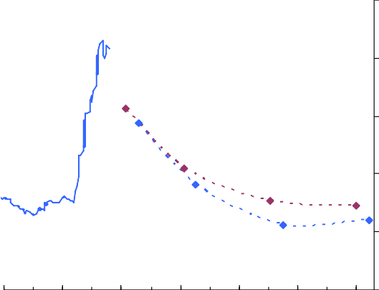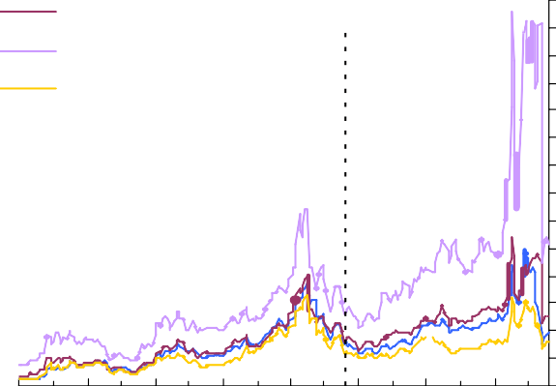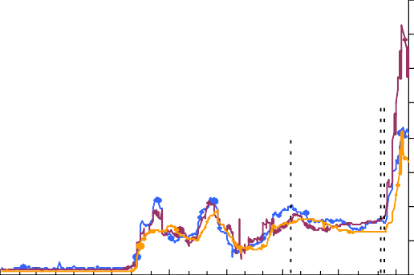

|  |
| --- |
| **Chart 9: Dynamic provisioning** |
| Specific provisions as a percentage of total loans General provisions as a percentage of total loans  Total provisions as a percentage of total loans Per cent of total loans  Upswing Downturn  0  Time |
| **Table 1: Key actions to improve resilience** |
| * Macroprudential tools are needed to guard against systemic risk * Capital levels need to rise and need to be of sufficient quality * Liquidity standards should be strengthened * Strengthen the legal framework for depositor protection and bank resolution * Better management of cross-border financial institutions * More disclosure, including potential future balance sheet volatility * Developing centralised infrastructures for over-the-counter instruments |

